Django Flash Messages

**Summary**: in this tutorial, you’ll learn how to use Django flash message messages including creating flash messages and displaying them.

# Introduction to the Django Flash Messages

A flash message is a one-time notification message. To display the flash message in Django, you use the messages from django.contrib module:

from django.contrib import messages

The messages have some useful functions for displaying information, warning, and error messages:

 messages.debug – displays a debug message.

 messages.info – displays an informational message.

 messages.success – displays a success message.  messages.warning – displays a warning message.  messages.error – displays an error message.

All of these functions accept an HttpRequest object as the first argument and a message as the second argument.

# Django Flash message example

We’ll implement flash messages for the blog app in the django_project .

## Creating Django flash messages

Modify the create_post() function by adding the flash messages:

from django.shortcuts import render,redirect from django.contrib import messages

from .models import Post from .forms import PostForm

def create_post(request):

if request.method == 'GET': context = {'form': PostForm()}

return render(request,'blog/post_form.html',context)

elif request.method == 'POST': form = PostForm(request.POST) if form.is_valid():

form.save()

messages.success(request, 'The post has been created successfully.') return redirect('posts')

else:

messages.error(request, 'Please correct the following errors:') return render(request,'blog/post_form.html',{'form':form})

How it works.

First, import messages from the django.contrib :

from django.contrib import messages

Second, create a success message after saving the form values into the database by calling the

success() function:

messages.success(request, 'The post has been created successfully.')

Third, create an error message if the form is not valid by calling the error() function:

messages.error(request, 'Please correct the following errors:')

## Displaying flash messages

Modify the base.html template to display flash messages:

{%load static %}



<!DOCTYPE html>

<html lang="en">

<head>

<meta charset="UTF-8" />

<meta name="viewport" content="width=device-width, initial-scale=1.0" />

<link rel="stylesheet" href="{% static 'css/style.css' %}" />

<script src="{% static 'js/app.js' %}" defer></script>

<title>My Site</title>

</head>

<body>

{% if messages %}

<div class="messages">

{% for message in messages %}

<div class="alert {% if message.tags %}alert-{{ message.tags

{{ message }}

</div>

{% endfor %}

</div>

{% endif %}

{%block content%}

{%endblock content%}

</body>

</html>

If you navigate to the form <http://127.0.0.1/post/create> , enter the values, and click the Save button:

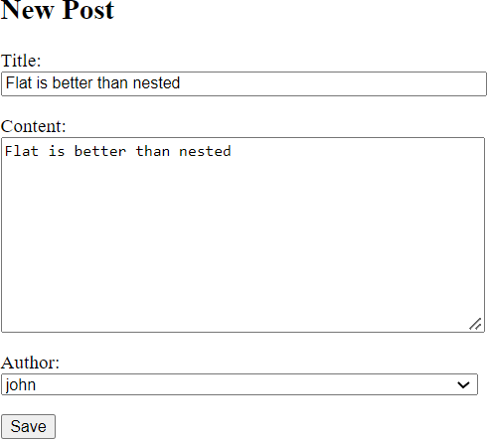

… you’ll see a success message:

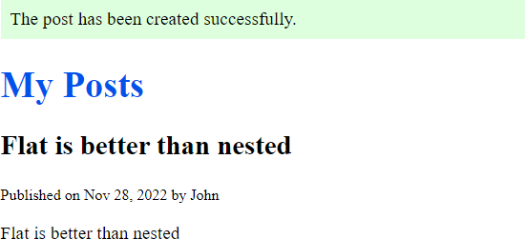

If you refresh the page, the message will disappear because it displays only once. When you skip entering a value for the title field and click the Save button:

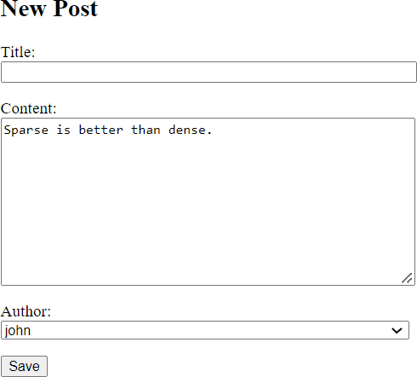

… you’ll see an error message:

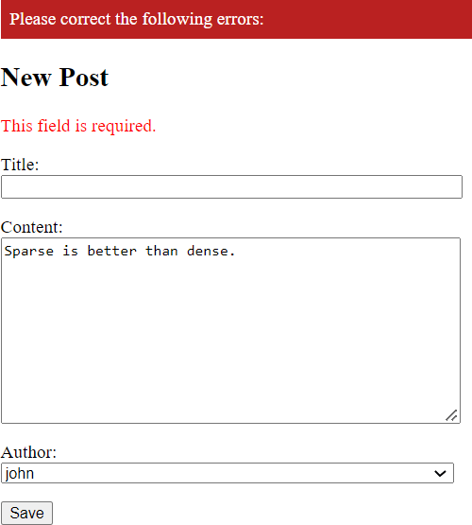

# Summary

 Use the messages from django.contrib to create and display messages.